Live Lecture 2

Class test Summary
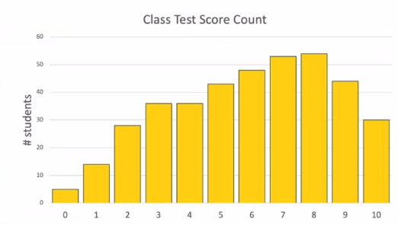
The most difficult question: (The value printed is 22!)
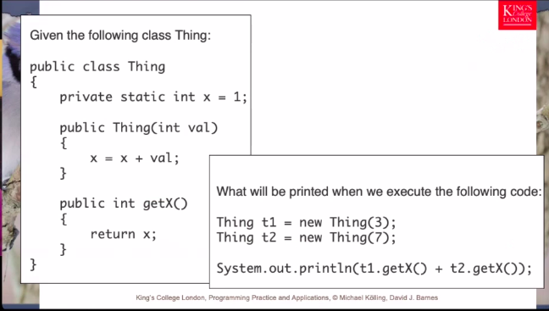

Coursework 2 Summary
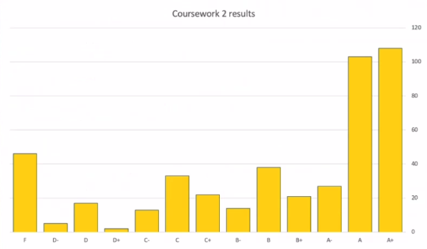

Inheritance
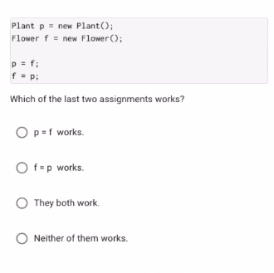

A is the right answer! - All flowers are plants but not all plants are flowers (trees).

